Ex. No. 3 | Responsive Webpages
Date of Exercise | 10.08.2026
GitHub Host Link | https://praneettigga.github.io/web-tech-lab/
Aim
To make the Zen Spaces Interior Design Studio website responsive using the viewport meta tag, flexible images, Flexbox, CSS Grid and CSS media queries so that the pages adjust automatically to desktop, tablet and mobile screen sizes.
Description
Responsive Web Design (RWD): An approach in which the same webpage adapts its layout to the screen width (desktop, tablet or mobile) instead of building a separate site for every device.
Viewport meta tag: <meta name="viewport" content="width=device-width, initial-scale=1.0"> makes the browser use the real device width at a 1:1 zoom; without it, mobile browsers shrink the desktop layout and media queries do not work properly.
External CSS: The responsive rules are written in a separate file, responsive.css, and linked to the pages inside <head> using <link rel="stylesheet" href="../responsive.css">. The home page keeps its colors and layout in an internal <style> block.
Box sizing: * { box-sizing:border-box; } makes padding and border part of an element's width, so elements with 100% width do not overflow the screen.
Flexible images and media: img, video, iframe { max-width:100%; height:auto; } stops images from becoming wider than their container and keeps their aspect ratio when the screen shrinks.
Flexbox navigation bar: display:flex with flex-wrap:wrap and gap on the navigation list lets the menu items wrap onto the next line on narrow screens instead of overflowing.
CSS Grid gallery: display:grid with grid-template-columns: repeat(2, minmax(0, 1fr)) lays out the gallery images in two equal columns, and the images fill their cell using width:100%.
CSS media queries: @media only screen and (max-width:600px) applies a block of CSS only on screens narrower than 600px. Here it stacks the menu vertically, reduces the margin and padding of the sections, makes the table scrollable (overflow-x:auto) and changes the gallery to one column.
HTML structure: Headings, paragraphs, hyperlinks, images, tables, definition list (<dl>), ordered and unordered lists are used to build the Zen Spaces Interior Design Studio pages: home, gallery, projects, about us and contact.
Procedure:
1. Select the website to be made responsive: the Zen Spaces Interior Design Studio website.
2. Create a folder Expt3 with home.html, an images folder, a pages folder (gallery.html, projects.html, about-us.html, contact.html) and a stylesheet responsive.css.
3. Add the viewport meta tag <meta name="viewport" content="width=device-width, initial-scale=1.0"> inside the <head> of every page.
4. In responsive.css, set box-sizing:border-box for all elements.
5. Make the images, videos and iframes flexible with max-width:100% and height:auto.
6. Style the navigation list as a flex container with flex-wrap:wrap and a gap so that the menu items wrap on small screens.
7. Create the gallery as a CSS Grid with two equal columns (repeat(2, minmax(0, 1fr))) and a 20px gap, and make the gallery images fill their cells.
8. Add the media query @media only screen and (max-width:600px) to show the menu in a column, reduce the section margin and padding, make the table horizontally scrollable and show the gallery in a single column.
9. Link responsive.css in the <head> of every page inside the pages folder using <link rel="stylesheet" href="../responsive.css">.
10. In home.html, style the navigation bar, sections, table and lists with internal CSS and link the pages with the navigation menu.
11. Save the files, open home.html in a browser and resize the window (or use the browser's device toolbar) to check the desktop, tablet and mobile layouts.
12. Push the code to GitHub and host it using GitHub Pages to obtain the deployment link.
Program
home.html
<!DOCTYPE html>
<!--URK24CS1040-->
<!--Website Theme : Interior Design Studio-->
<html lang="en">
<head>
<meta name="viewport" content="width=device-width, initial-scale=1.0" charset="UTF-8">
<title>Interior Design Studio</title>

<style>
body {
background-color: #f8f5ef;
color: #2f3e2f;
font-family: Arial, sans-serif;
margin: 0;
padding: 0;
}

.navbar, .hero-section, .welcome-section, .project-section, .services-section, .contact-section {
padding: 20px;
margin: 20px;
border-radius: 10px;
background-color: #fffdf8;hange the layout of a page depending on the orientation of the screen.

Here, we change the background-color of the body, if the screen orientation is in landscape mode:
}

.navbar {
background-color: #1f4d3a;
color: white;
}

.navbar h1 {
color: #d4af37;
}

.navbar ul {
list-style-type: none;
padding: 0;
}

.navbar li {
display: inline;
margin-right: 15px;
}

.navbar a {
color: #f5e6a8;
text-decoration: none;
}

.navbar a:hover {
color: #ffd700;
}

h1, h2, h3, h4 {
color: #1f4d3a;
}

a {
color: #b8860b;
text-decoration: none;
}

a:hover {
text-decoration: underline;
color: #8b6f1e;
}

img {
border: 3px solid #d4af37;
border-radius: 8px;
margin-top: 10px;
}

table {
width: 100%;
border-collapse: collapse;
margin-top: 15px;
background-color: white;
}

th {
background-color: #1f4d3a;
color: white;
}

th, td {
border: 1px solid #c8b273;
padding: 10px;
text-align: center;
}

dl, ol, ul {
margin-top: 10px;
margin-bottom: 10px;
}

dt {
font-weight: bold;
color: #1f4d3a;
}

dd {
margin-bottom: 10px;
}

hr {
border: 1px solid #d4af37;
}
</style>
</head>
<body>

<!-- Navigation Section -->
<div class="navbar" id="top">
<h1>ZEN SPACES</h1>
<ul>
<li><a href="#home">Home</a></li>
<li><a href="pages/gallery.html">Gallery</a></li>
<li><a href="#projects">Projects</a></li>
<li><a href="pages/about-us.html">About Us</a></li>
<li><a href="pages/contact.html">Contact</a></li>
</ul>
<hr>
</div>

<!-- Hero Section -->
<div class="hero-section" id="home">
<h1>India's Most Trusted Interior Company</h1>
<h2>Crafting Elegant and Functional Interior Design</h2>
<h2>Kitchen | Bedroom | Living | Dining</h2>
<a href="https://github.com/praneettigga/web-tech-lab" target="_blank" rel="noopener noreferrer">
<img src="images/interior-1.jpg" alt="Modern Living Room Interior" width="300">
</a>
<p><a href="#projects">View Our Projects</a></p>
<hr>
</div>

<!-- Welcome Section -->
<div class="welcome-section" id="welcome">
<h3>Welcome to Zen Spaces</h3>
<h4>Welcome to our award winning Interior Design Studio</h4>
<p>
We specialize in creating stylish, innovative, and functional interiors that blend
creative aesthetics with practical design solutions.
</p>
<p>
Every space we design is thoughtfully crafted to reflect our clients’ personality and
lifestyle, while maintaining a modern and sophisticated look.
</p>
<p>
With a fresh perspective and high-end execution, we turn ideas into inspiring spaces.
</p>
<p>You can visit this website's GitHub at:</p>
<a href="https://github.com/praneettigga/web-tech-lab" target="_blank" rel="noopener noreferrer">GitHub</a>
</div>

<!-- Project Section -->
<div class="project-section" id="projects">
<h3>Projects</h3>
<p>Here are some of our featured interior design projects.</p>

<table>
<tr>
<th>Project Image</th>
<th>Project Name</th>
<th>Room Type</th>
<th>Style</th>
</tr>
<tr>
<td>
<a href="https://github.com/praneettigga/web-tech-lab" target="_blank" rel="noopener noreferrer">
<img src="images/interior-1.jpg" alt="Modern living room interior project" width="200">
</a>
</td>
<td>Urban Elegance</td>
<td>Living Room</td>
<td>Modern</td>
</tr>
<tr>
<td>
<a href="https://github.com/praneettigga/web-tech-lab" target="_blank" rel="noopener noreferrer">
<img src="images/interior-2.jpg" alt="Elegant bedroom interior project" width="200">
</a>
</td>
<td>Serene Retreat</td>
<td>Bedroom</td>
<td>Minimalist</td>
</tr>
<tr>
<td>
<a href="https://github.com/praneettigga/web-tech-lab" target="_blank" rel="noopener noreferrer">
<img src="images/interior-3.jpg" alt="Contemporary dining room interior project" width="200">
</a>
</td>
<td>Golden Feast</td>
<td>Dining Room</td>
<td>Contemporary</td>
</tr>
</table>
</div>

<!-- Services and Design Details Section -->
<div class="services-section" id="services">
<h3>Our Services and Design Process</h3>
<p>Zen Spaces offers complete interior design solutions for modern homes and apartments.</p>

<dl>
<dt>Modular Kitchen</dt>
<dd>Smart kitchen layouts with modern cabinets, storage units, and elegant finishes.</dd>

<dt>Bedroom Interiors</dt>
<dd>Comfortable and stylish bedroom designs with wardrobes, lighting, and custom furniture.</dd>

<dt>Living Room Design</dt>
<dd>Beautiful living spaces designed for comfort, family interaction, and visual appeal.</dd>
</dl>

<ol>
<li>Design Consultation
<ol>
<li>Understand client requirements</li>
<li>Discuss budget and space planning</li>
</ol>
</li>
<li>Concept Development
<ol>
<li>Create layout ideas</li>
<li>Select materials and colors</li>
</ol>
</li>
<li>Execution
<ol>
<li>Install furniture and decor</li>
<li>Complete final finishing</li>
</ol>
</li>
</ol>

<ul>
<li>Rooms We Design
<ul>
<li>Living Room</li>
<li>Bedroom</li>
<li>Dining Room</li>
</ul>
</li>
<li>Design Styles
<ul>
<li>Modern</li>
<li>Minimalist</li>
<li>Contemporary</li>
</ul>
</li>
</ul>
</div>

<!-- Contact Section -->
<div class="contact-section" id="contact-home">
<h3>Contact Us</h3>
<p>Email: <a href="mailto:customerservice@zenspaces.com">customerservice@zenspaces.com</a></p>
<p>Phone: <a href="tel:+9123456789">+91 23456 789</a></p>
</div>

</body>
</html>
responsive.css
/* Responsive Web Design rules for the viewport, grids, media, and small screens. */
* {
box-sizing: border-box;
}

img,
video,
iframe {
max-width: 100%;
height: auto;
}

.navbar ul {
display: flex;
flex-wrap: wrap;
gap: 10px 15px;
}

.navbar li {
margin-right: 0;
}

.gallery-grid {
display: grid;
grid-template-columns: repeat(2, minmax(0, 1fr));
gap: 20px;
padding: 0;
list-style: none;
}

.gallery-grid li {
min-width: 0;
}

.gallery-grid img {
display: block;
width: 100%;
}

@media only screen and (max-width: 600px) {
.navbar ul {
flex-direction: column;
align-items: flex-start;
gap: 10px;
}

.navbar li {
display: block;
}

.hero-section,
.welcome-section,
.project-section,
.services-section,
.contact-section {
margin: 12px;
padding: 16px;
}

table {
display: block;
overflow-x: auto;
}

.gallery-grid {
grid-template-columns: 1fr;
}
}
pages/gallery.html
<!DOCTYPE html>
<html lang="en">
<head>
<meta name="viewport" content="width=device-width, initial-scale=1.0" charset="UTF-8">
<title>Gallery</title>
<link rel="stylesheet" href="../responsive.css">
</head>

<body style="background-color: white;">

<!-- Navigation Section -->
<div class="navbar" id="top">
<h1>ZEN SPACES</h1>
<ul>
<li><a href="../home.html">Home</a></li>
<li><a href="gallery.html">Gallery</a></li>
<li><a href="projects.html">Projects</a></li>
<li><a href="about-us.html">About Us</a></li>
<li><a href="contact.html">Contact</a></li>
</ul>
<hr>
</div>

<h1>Gallery Page</h1>

<ul class="gallery-grid">
<li><img src="../images/interior-1.jpg" alt="Modern living room interior"></li>
<li><img src="../images/interior-2.jpg" alt="Elegant bedroom interior"></li>
<li><img src="../images/interior-3.jpg" alt="Stylish dining room interior"></li>
<li><img src="../images/interior-4.jpg" alt="Luxury modular kitchen interior"></li>
</ul>
</body>
</html>
pages/projects.html
<!DOCTYPE html>
<html lang="en">
<head>
<meta name="viewport" content="width=device-width, initial-scale=1.0" charset="UTF-8">
<title>Projects</title>
<link rel="stylesheet" href="../responsive.css">
</head>

<body style="background-color: white;">

<!-- Navigation Section -->
<div class="navbar" id="top">
<h1>ZEN SPACES</h1>
<ul>
<li><a href="../home.html">Home</a></li>
<li><a href="gallery.html">Gallery</a></li>
<li><a href="projects.html">Projects</a></li>
<li><a href="about-us.html">About Us</a></li>
<li><a href="contact.html">Contact</a></li>
</ul>
<hr>
</div>

<h1>Projects Page</h1>

<div>
<p>This page is still in progress...</p>
</div>

</body>
</html>
pages/about-us.html
<!DOCTYPE html>
<html lang="en">
<head>
<meta name="viewport" content="width=device-width, initial-scale=1.0" charset="UTF-8">
<title>About Us</title>
<link rel="stylesheet" href="../responsive.css">
</head>

<body style="background-color: white;">

<!-- Navigation Section -->
<div class="navbar" id="top">
<h1>ZEN SPACES</h1>
<ul>
<li><a href="../home.html">Home</a></li>
<li><a href="gallery.html">Gallery</a></li>
<li><a href="projects.html">Projects</a></li>
<li><a href="about-us.html">About Us</a></li>
<li><a href="contact.html">Contact</a></li>
</ul>
<hr>
</div>

<h1>About Us</h1>

<div>
<p>“Made for you” may be an accurate phrase to express what we do in interiors. We have been designing and executing exquisite home interiors since 2004. Custom-made interior is the best way to ensure that modular kitchen, wardrobes and other furniture perfectly fits to the spaces. Our interior designers possess impeccable ability to understand client’s requirements and provide the best space planning for a house or flat. D’LIFE’s fully equipped modular kitchen is distinct with its unique design and most modern features. We plan and make contemporary style furniture for bedrooms, living and dining rooms as well. Innovative ideas, creative designs and ability to deliver the promises on time enables us to retain the leadership in this field.</p>
</div>

</body>
</html>
pages/contact.html
<!DOCTYPE html>
<html lang="en">
<head>
<meta name="viewport" content="width=device-width, initial-scale=1.0" charset="UTF-8">
<title>Contact</title>
<link rel="stylesheet" href="../responsive.css">
</head>

<body style="background-color: white;">

<!-- Navigation Section -->
<div class="navbar" id="top">
<h1>ZEN SPACES</h1>
<ul>
<li><a href="../home.html">Home</a></li>
<li><a href="gallery.html">Gallery</a></li>
<li><a href="projects.html">Projects</a></li>
<li><a href="about-us.html">About Us</a></li>
<li><a href="contact.html">Contact</a></li>
</ul>
<hr>
</div>

<div>
<h1>Contact The Best Home Interior Designers at:</h1>
<a href = "mailto:customerservice@zenspaces.com">Email: customerservice@zenspaces.com</a>
<br>
<a href = "tel:+9123456789">Phone: +9123456789</a>
</div>

</body>
</html>
Output
Home Page - Desktop View (1200px)
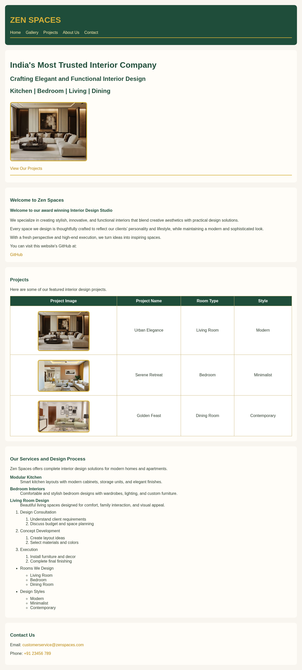
Figure 1: Home page in desktop view (1200px)
Home Page - Tablet View (768px)
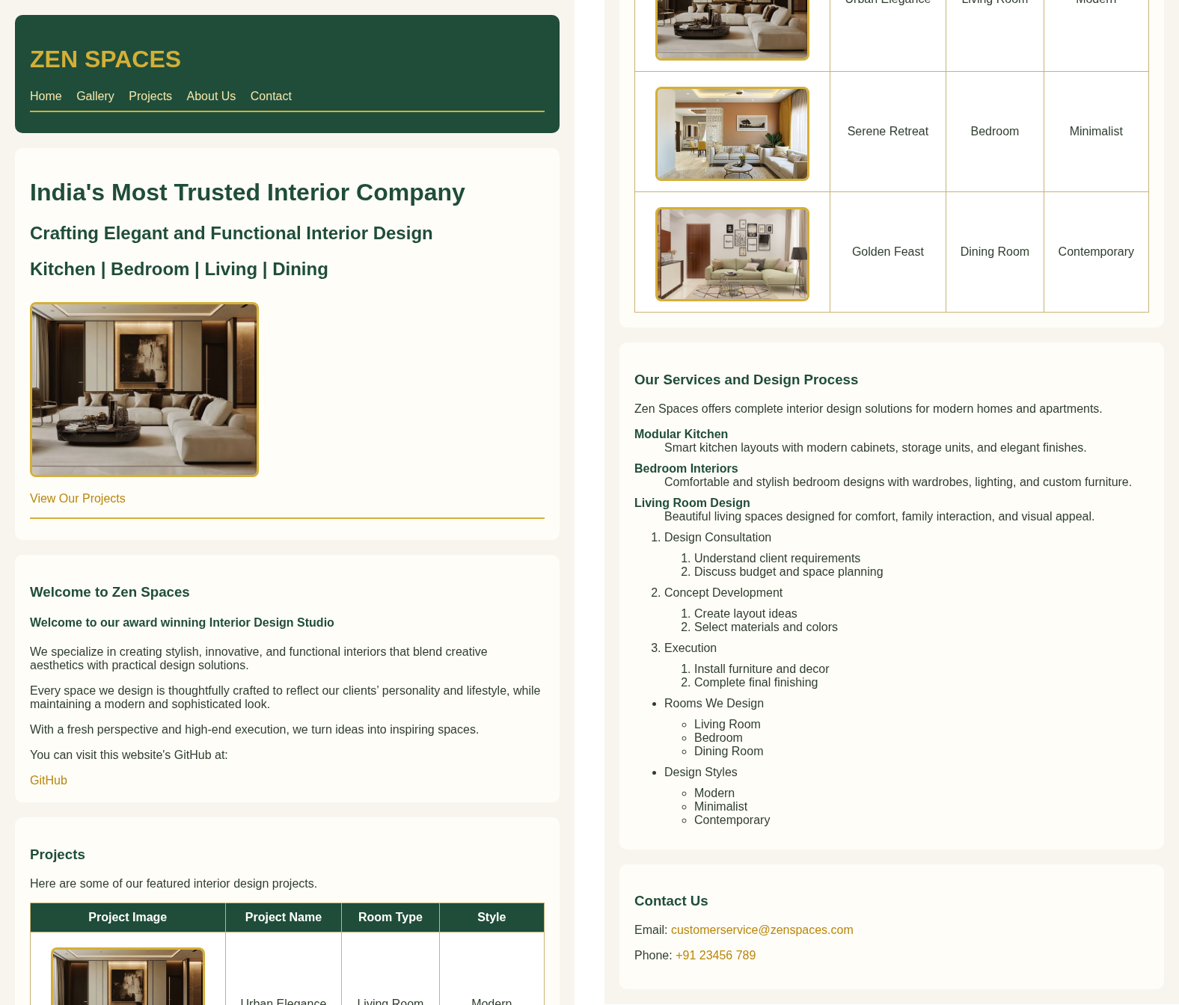
Figure 2: Home page in tablet view (768px), shown in two halves side by side
Home Page - Mobile View (400px)
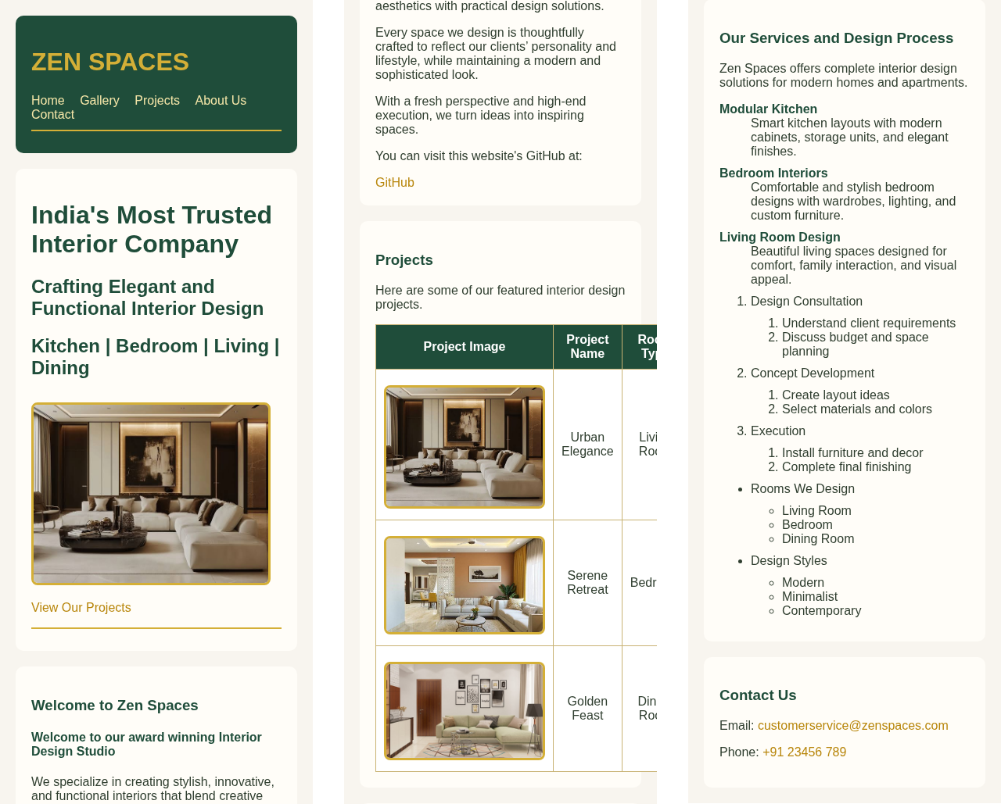
Figure 3: Home page in mobile view (400px), shown in three parts side by side
Gallery Page - Desktop View (1200px)
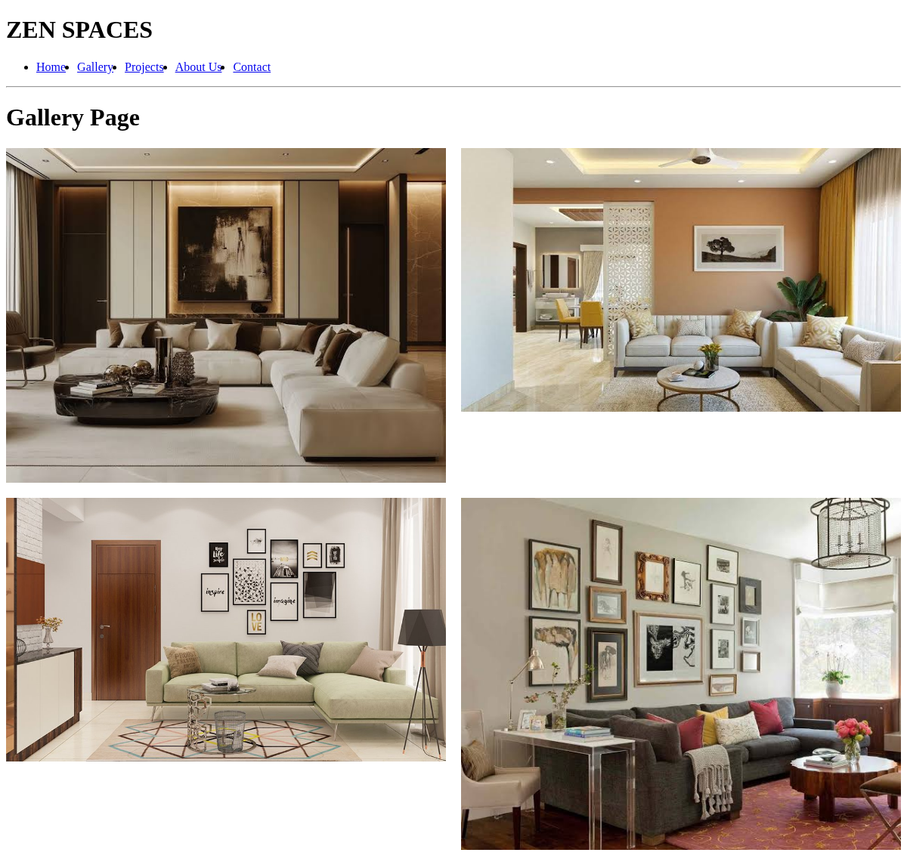
Figure 4: Gallery page in desktop view with the two-column grid
Gallery Page - Tablet (768px) and Mobile (400px) Views
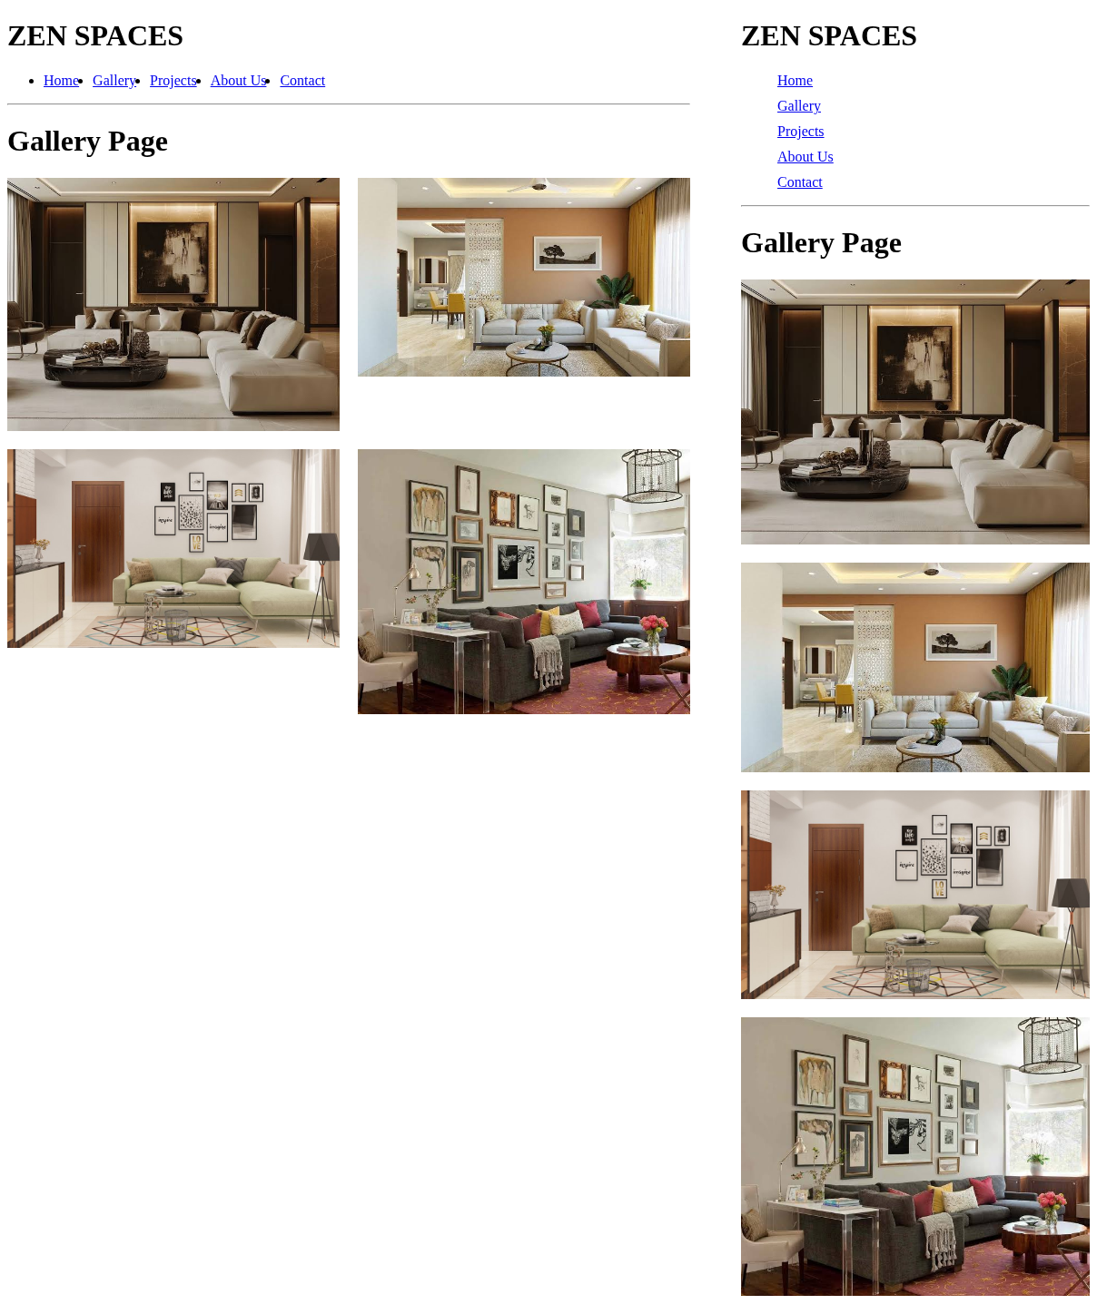
Figure 5: Gallery page in tablet view (left, two columns) and mobile view (right, single column)
Result
The Zen Spaces Interior Design Studio website was successfully made responsive using the viewport meta tag, flexible images, Flexbox, CSS Grid and a media query in responsive.css. The pages adjusted correctly to desktop, tablet and mobile screen sizes: the menu became vertical and the gallery changed from two columns to one column on small screens.

